Room hire

at the

Carers Support Centre

WE ARE HERE

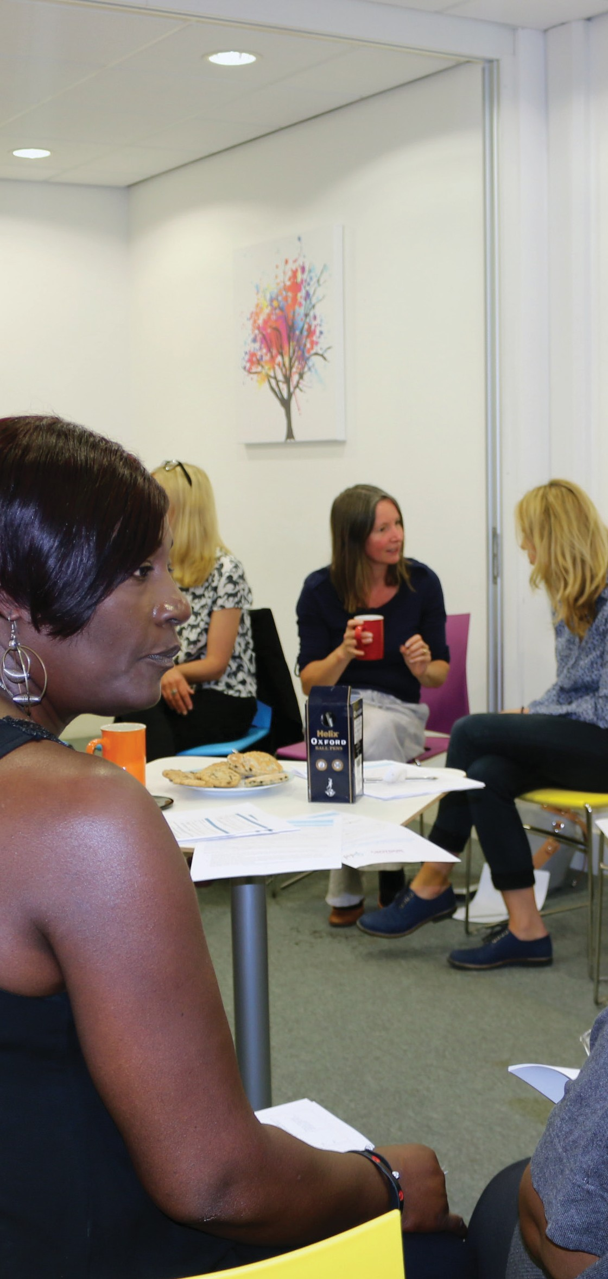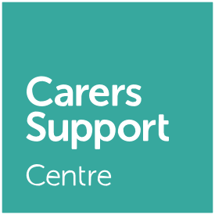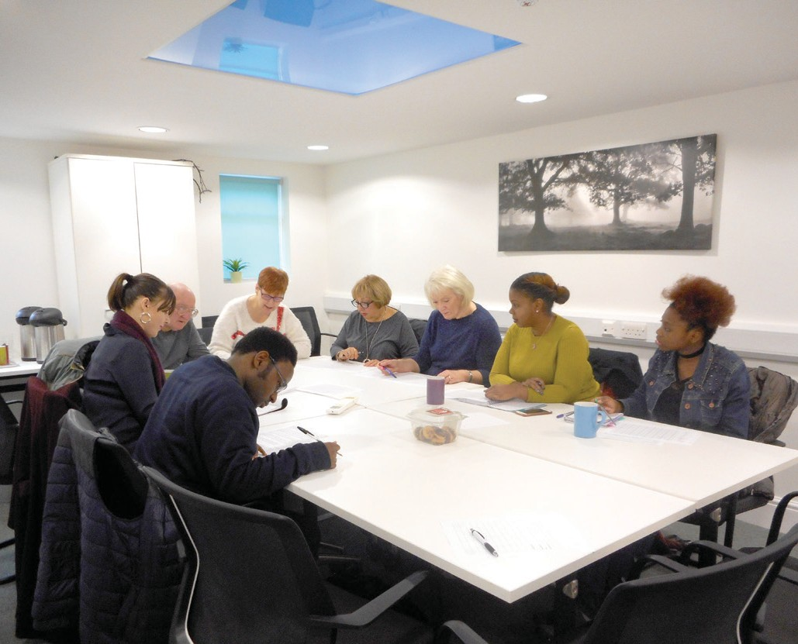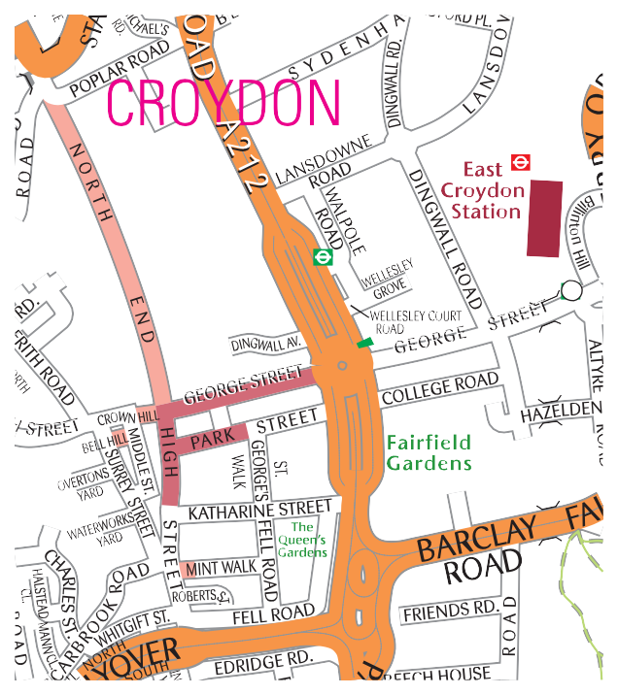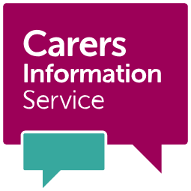“All staff friendly and welcoming… nothing is too much trouble.”

Why choose us?
- Bright, welcoming environment
- Convenient public transport links to central London/rest of Croydon
- Highly competitive rates
- Friendly staff and flexible service
- Layout to suit your requirements (boardroom, theatre, cabaret, etc.)
- Accessible for wheelchair users
(except boardroom)
- WiFi access in all rooms
- Screen and projector, flipchart and refreshments available*
* please note these services come with
an additional charge

Contact:
Call: 020 8663 5600
Email: bookings@carersinfo.org.uk
Visit: Carers Support Centre, 24 George Street, Croydon CR0 1PB
Online: www.carersinfo.org.uk/room-hire

How to get here:
Tram: Directly opposite George Street tram stop
Train: Short walk from East/West Croydon stations (National Rail, London Overground)
Bus: Nearest bus stops Park Street and Whitgift
Centre
Parking: NCP Croydon Central, Dingwell Avenue

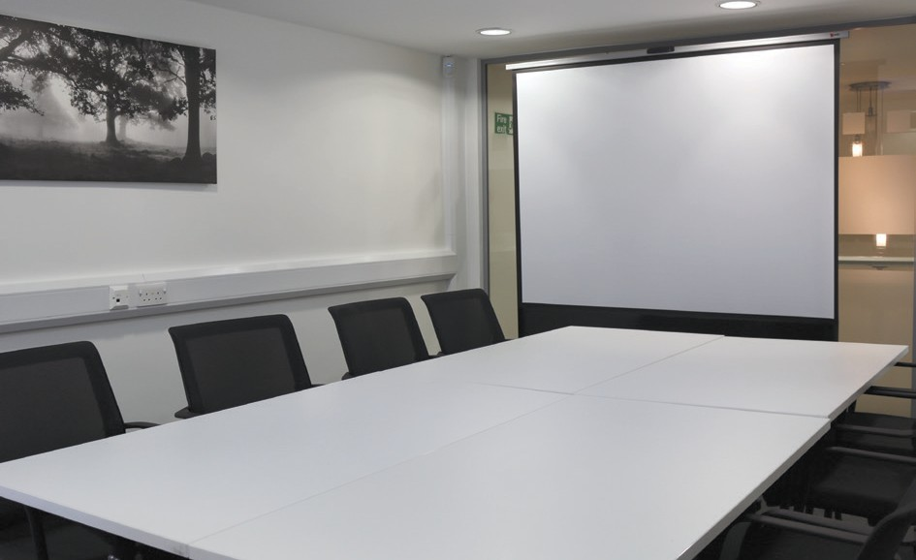

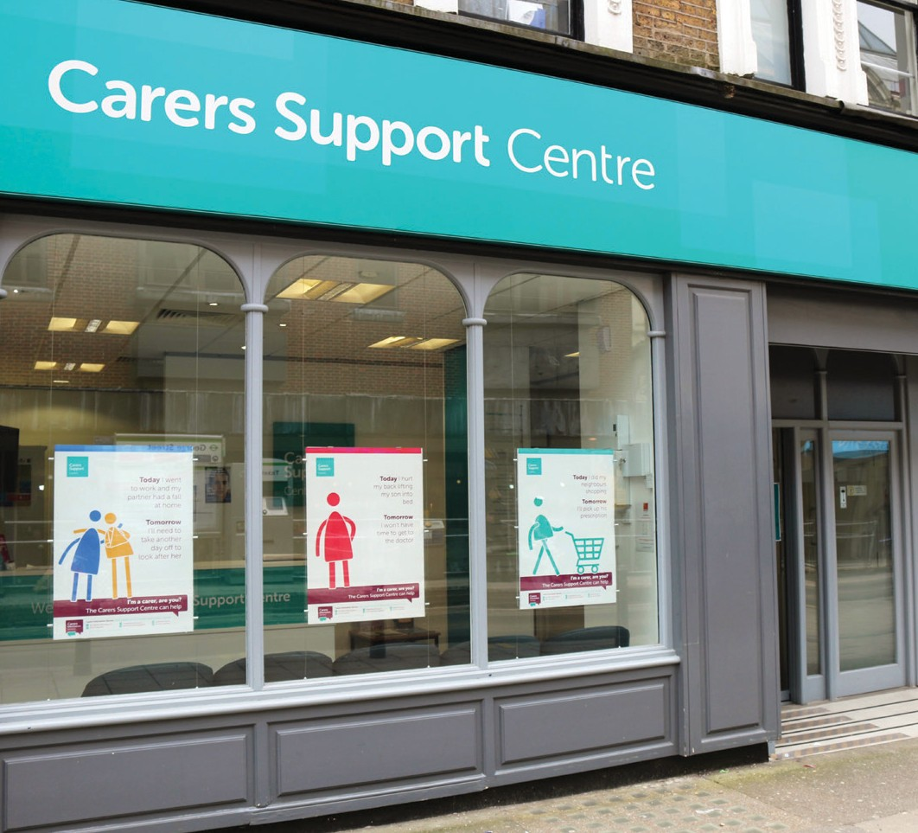Looking for affordable room hire? Want a bright, friendly venue that makes people feel welcome?
Look no further than the Carers Support Centre. Based at the heart of Croydon with convenient public transport links to central London, we offer a friendly, flexible room hire service at highly competitive rates.

About the centre
The Carers Support Centre is the flagship hub for carers support services in Croydon. It is run by the Carers’ Information Service, in partnership with the Whitgift Foundation and Croydon Council.

Our rooms
Rooms to hire include an executive boardroom, private consultation rooms and fully functional meeting rooms. Booking times are Monday to Friday, 9.30am - 4.30pm.
For more information, call 020 8663 5600 or email bookings@carersinfo.org.uk.

Joan Harris Boardroom**
A modern, executive-style boardroom with a capacity of 20 seated or 25 standing. The room benefits from natural daylight and is ideal for training, interviews, events and meetings.
Prices start from £77* per three hour session.

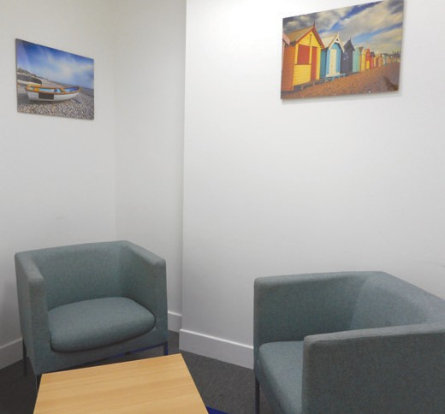Consultation
rooms
Our private consultation rooms are ideal for one- to-one sessions and counselling, with prices starting at just £16.50* per hour.

Meeting rooms
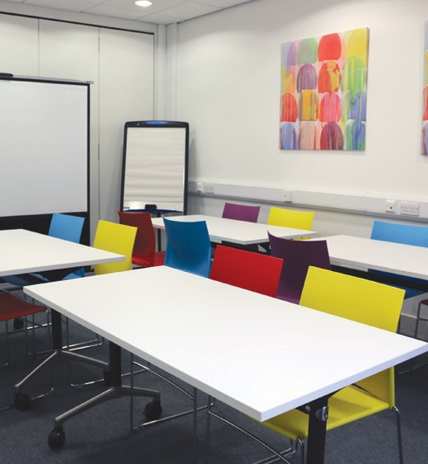Our bright and friendly meeting rooms are perfect for events, training and community groups, with a maximum capacity of up to 52 standing or 35 seated. Prices start at
£44* per three hour
session.
* Correct at time of print.
Please note prices may be subject to change.
** Please note this room is not wheelchair accessible.

Range of facilities
Layouts to suit your requirements
Cabaret
Theatre
Boardroom
Circle

WiFi refreshments
and Café area*
*additional charges apply

Book today
Call:
020 8663 5600
Email:
bookings@carersinfo.org.uk
Online:
www.carersinfo.org.uk/room-hire
Visit:
Carers Support Centre,
24 George Street, Croydon CR0 1PB

laptop and
projector*

